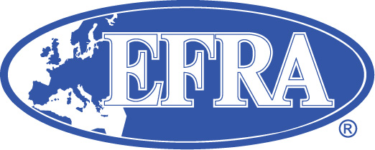

EFRA European Championship minimum requirements checklist

National Federation details:

Single point contact details:

Track details:

Surface
Length overall

Length of the main straight

Width, minimum and maximum

Lap time (fastest)

Drainage (outdoor)
Safety barrier construction?

Results board type?

Scoreboard electronic?

Previous events, detail types?

Race Organisation:

Number of staff
Lap counting program?
Live timing?

Race director?
National referee?
Timekeeper
Technical inspector
Security provider

Rostrum
Covered? Y/N
Length? ………m
Stairs up Y/N
Stairs down Y/N
Referees area Y/N
Media area Y/N
Disabled access Y/N
Separate PA system? Y/N

Pit Area….
Maximum number of drivers
Area per driver
All chairs are provided? Y/N

Radio frequencies:

Insurance from

Medical cover from

Practice facility dates

Accommodation….

Please list three Hotels or hostels

Details of camping facilities

Transport between hotels and track

Voltage and plug type?

Location
Latitude and longitude, GPS and ZIP/PO code

Identity badges, required? Y/N

Wi-Fi facilities?
Wi-Fi speed?

Please add:

A plan or drawing of the venue highlighting:

Track and loop positions and direction of driving.
Parking and storage areas.
Access for emergency vehicles.
Pit Area.
Food and rest areas.
Rostrum.
Timekeeping area.
Maps showing the location of track to public transport.
Photographs are also permissible.

Please refer to the EFRA handbook EFRA Sanctions rule 3.2.2 for the complete requirements.

